

**Amazon Sales Report**

By- Shivangi Gupta





June 3, 2024

# **Executive Summary**

This study delves deeply into the sales data analysis from the most recent project. The study examines sales performance, product analysis, fulfilment techniques, customer segmentation, and order statuses. Key insights and ideas are presented to help improve sales strategy, inventory management, and customer service.

# **Dataset Overview**

The dataset contains information about sales transactions on Amazon, including details such as

1. **Order ID:** Unique identifier for each order.
2. **Order Date:** Date when the order was placed.
3. **Product Category:** Category of the product ordered.
4. **Size:** Size of the product ordered.
5. **Quantity Sold:** Number of units sold.
6. **Sales Amount:** Total sales amount for the order.
7. **Customer Location:** Location of the customer placing the order.
8. **Ship-City (District):** District of the customer placing the order.
9. **Fulfilment Method:** Method used to fulfil the order (Amazon or Merchant).
10. **Order Status:** Current status of the order (e.g., Delivered, Cancelled, Pending)

The objective is to conduct a comprehensive analysis of the data and extract actionable insights to support business decision-making.

### **Data Cleaning and Preparation**

1. **Date Formatting:**

* Standardize “Order Date” format to “DD-MM-YYYY”.

1. **Adding Derived Column:**

* Added derived column such as Month from the Order Date.

1. **Data Type Conversion:**

* Converted columns to appropriate data types, such as Order Date to Date, Quantity Sold and Amount to Numeric.

1. **Removing Unwanted Columns:**

* Removed columns such as Index, New, Pendings, Fulfilled- by, Currency, Sales Channel, Ship Service Level, Ship Country, B2B.

1. **Removing Duplicates:**

* Identified and removed 959 duplicate records based on Order ID to ensure each order is unique.

1. **Handling Missing Values:**

* Imputed missing “Amount” values with the mean corresponding to each product category.
* Filled missing values in “Ship-City (District)”, “Ship-State”, “Ship-Postal-Code” with Unknown.

1. **Standardizing Text:**

* Standardized text values in categorical columns such as “Status”, “Ship – State” and “Ship – City (District)” to ensure uniformity (e.g., correcting typos, ensuring consistent capitalization).

1. **Outliers:**

* 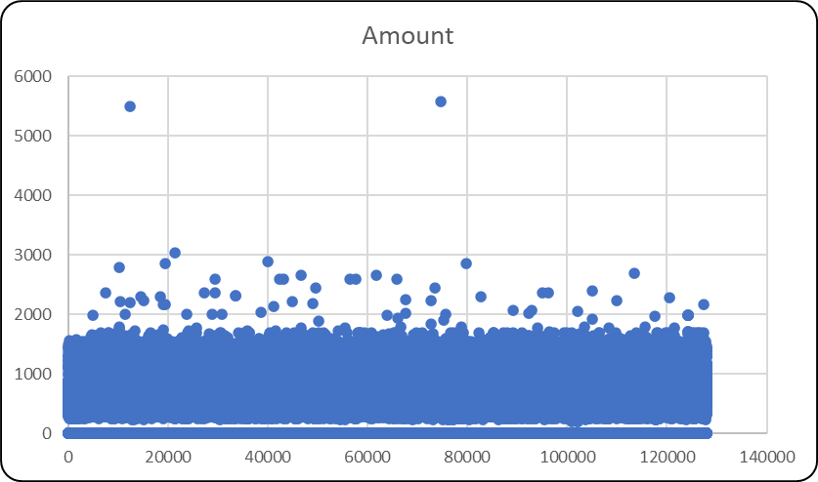Identified and managed outliers in “Amount” column.
* **High Values**: A few orders include much larger amounts than the majority. These anomalies might be the result of big purchases, high-value items.
* **Low Values:** Some orders have unusually small quantities, which might suggest special deals, discounts, or data inconsistencies.

#### **Sales Performance**

1. **Monthly Sales Performance**

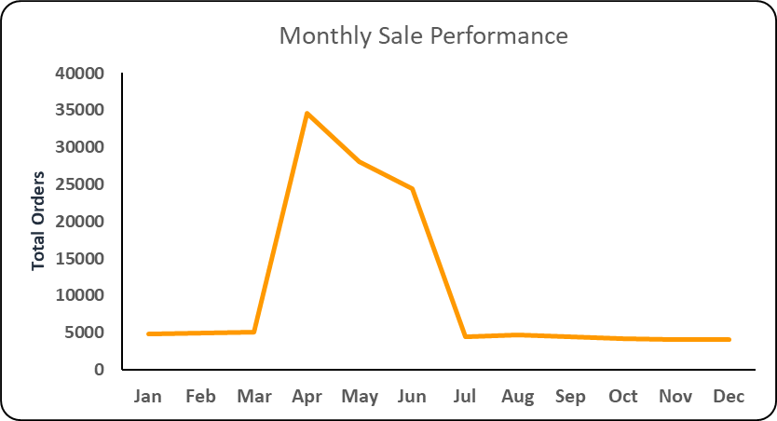

1. **Sales Growth Rate**

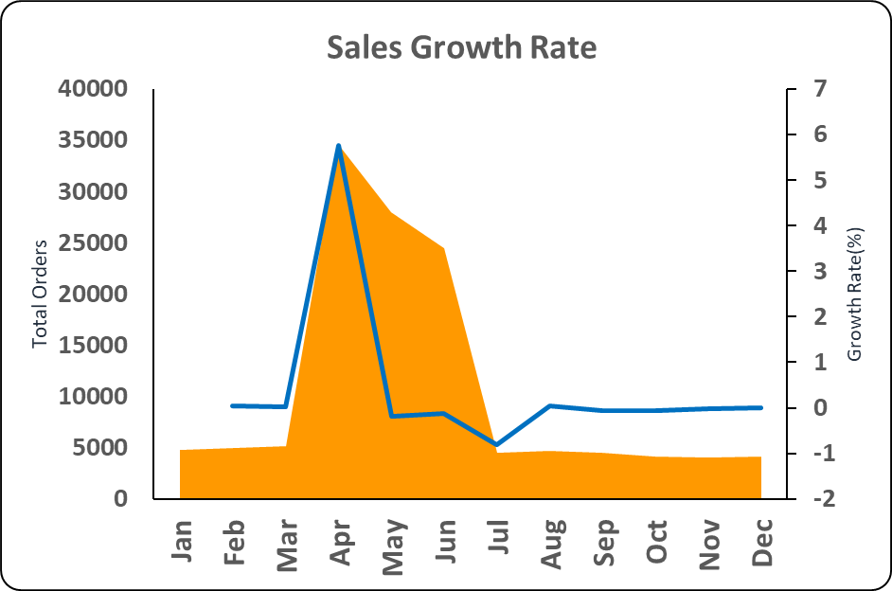

* **Sharp Increase**: Around April, there is a notable increase in orders.
* **Peak Period:** The biggest number of orders were placed in April.
* **Decline:** After May, the number of orders drops dramatically.
* **Low Activity:** Since August, the number of orders has been fairly low and consistent.
* **Growth Rate:** High growth rate in the months leading up to major holidays, indicating successful promotional campaigns.

###### **Product Analysis**

1. 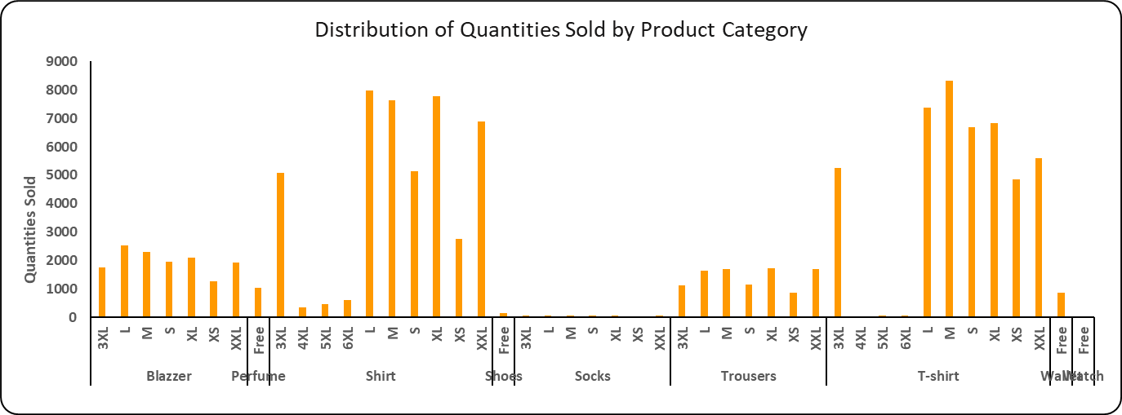Sales by Product Category

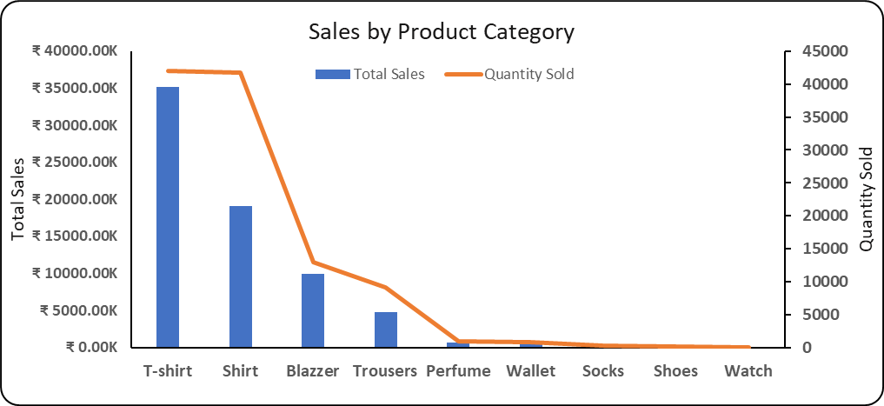

* **Popular Product Categories:** T-shirts and Shirts are the top-selling categories.
* **Popular Sizes:** Medium and Large sizes are the most popular.

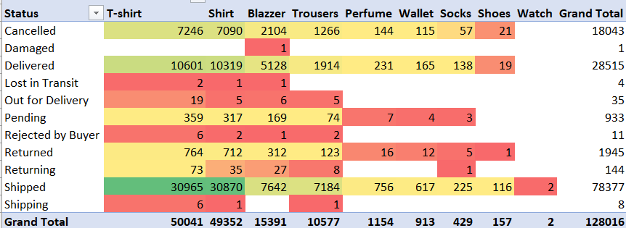**Order Status Analysis**

1. **High Delivered Orders:**

* T-shirts and Shirts lead in delivered orders, indicating strong demand.
* Blazers and Trousers also show significant delivery numbers.

1. **High Cancellation Rates**:

* T-shirts and Shirts have notable cancellation rates, hinting at sizing or expectation issues.
* Blazers and Trousers follow but with fewer cancellations.

1. **High Return Rates:**

* T-shirts and Shirts exhibit the highest returns, suggesting potential quality or fit problems.
* Blazers show a noticeable return rate as well.

1. **Efficient Fulfilment:**

* Few pending and lost in transit orders, indicating reliable order processing and delivery.

1. **Minimal Damage and Reaction:**

* Low reports of damaged goods and buyer rejections, reflecting good packaging and product satisfaction.

**Fulfilment Analysis**

1. 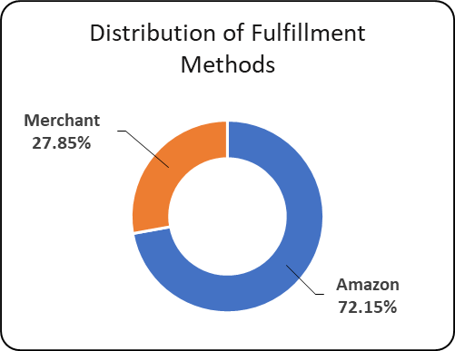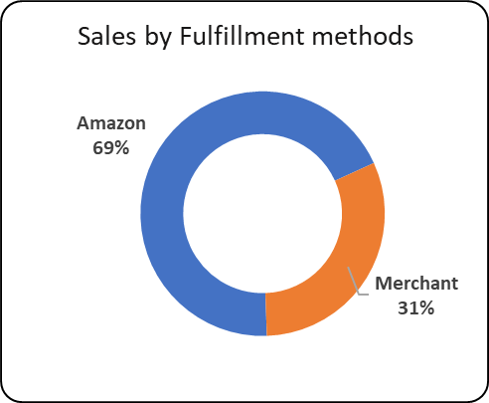**Distribution of fulfilment methods**
2. 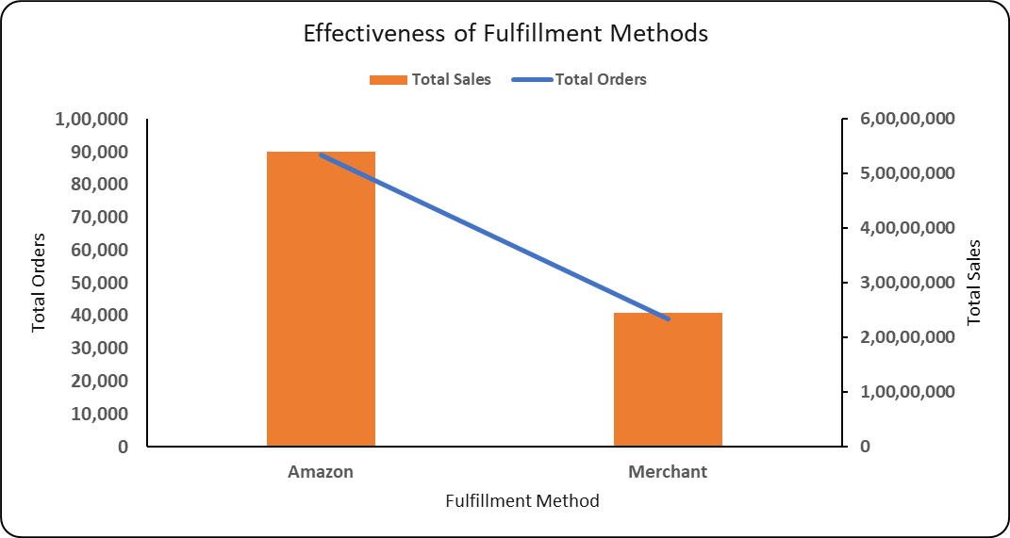**Effectiveness of Fulfilment methods**

* **Amazon Fulfilled:**

High efficiency in processing and delivering orders.

* **Merchant Fulfilled:**

Lower volume and sales compared to Amazon fulfilment, indicating potential for improvement in logistics and customer service.

**Geographical Analysis**

1. **Sales By State**

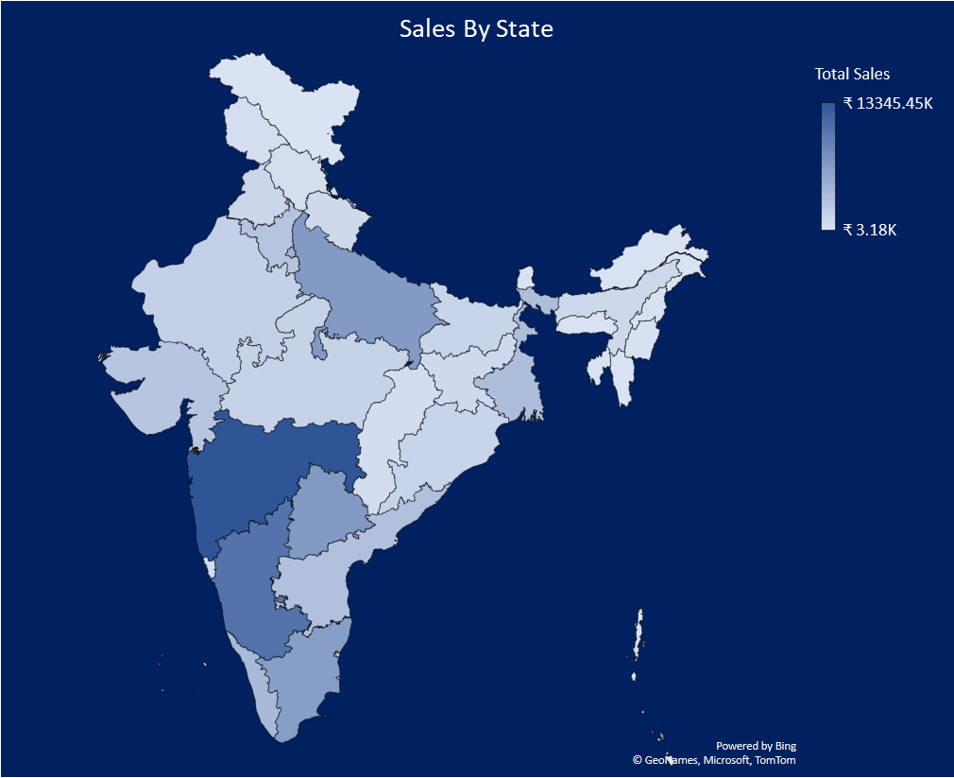

* **High-Performing States:**

**Maharashtra:** Shows the highest sales volume, as indicated by the darkest shade on the map.

**Karnataka and Tamil Nadu:** Also exhibit strong sales performance.

* **Low-Performing States:**

**Northeastern States:** Display lower sales volumes, suggesting potential areas for targeted marketing campaigns.

**Central India:** Some states in central India also have relatively lower sales.

1. **Top Performing Districts**

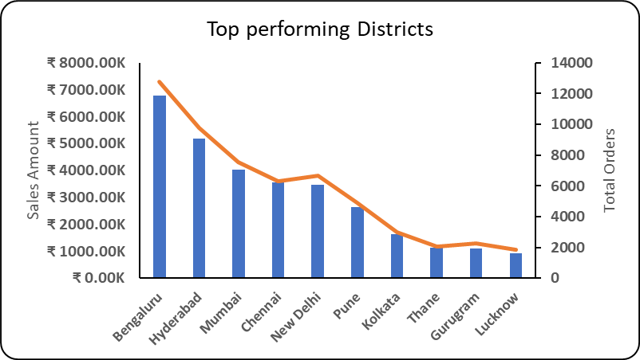

**Customer Segmentation**

1. **Top Order IDs with highest Sales and orders**

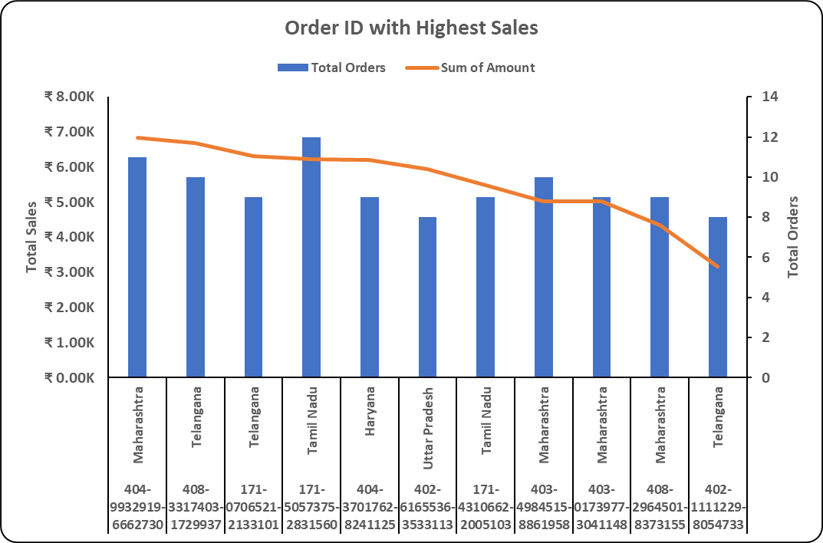

* **Top Customers by Order Volume:**

The top customers (based on Order ID) show a high level of repeat purchases.

* **Geographical Distribution:**

**Maharashtra:** This state shows the highest order frequency with multiple high-value customers.

**Telangana:** Telangana has significant contributions with customers placing high-frequency orders, indicating a strong market presence.

* **High-Value Customers:**

Customers placing the highest number of orders (e.g., 11 to 12 orders) are consistently generating high revenue, making them valuable for targeted marketing campaigns and loyalty programs.

* **Consistent Spending Patterns:**

Many customers show consistent spending patterns, with order amounts ranging between ₹3K to ₹7K.

* **Potential for Growth:**

Given the high concentration of orders and amounts from these states, there is a potential for growth by targeting similar customer demographics in neighbouring states or regions with similar profiles.

**Insights**

1. **Sales Trends:**

Orders increased significantly in April and May, followed by a dramatic fall.

1. **Product Analysis:**

• Top selling categories include t-shirts, shirts, and blazers.   
• Least Popular Categories: Watches and shoes had the fewest sales, indicating possible problems with product selection or marketing.

1. **Fulfilment Analysis:**

Amazon fulfils more orders and generates more revenue than Merchant**.**

1. **Geographic Analysis:**

* Sales by State: Maharashtra and Karnataka have larger sales.
* Sales By District: Bengaluru and Hyderabad have much bigger sales.

1. **Order Status Analysis:**

* Delivered Orders: The vast majority of orders are successfully delivered.
* Cancelled and Returned purchases: A large proportion of purchases are cancelled or returned, suggesting a problem with product quality or consumer expectations.

1. **Customer Segmentation:**

* Maharashtra: This state shows the highest order frequency with multiple high-value customers.
* Many customers show consistent spending patterns, with order amounts ranging between ₹3K to ₹7K.
* Customers placing the highest number of orders (e.g., 11 to 12 orders) are consistently generating high revenue, making them valuable for targeted marketing campaigns and loyalty programs.

**Recommendations**

1. Implement targeted promotions during high-sales periods (e.g., April and May) to capitalize on the sales spike.
2. To keep loyal consumers, provide loyalty programs to frequent purchases.
3. Ensure that top-selling categories such as T-shirts and shirts have enough supply levels to fulfil demand.
4. Stock more of the popular sizes. Consider offering special specials on less popular sizes to help balance inventories.
5. Analyse and fix issues in underperforming categories such as watches and shoes.
6. Investigate the causes of high cancellation and return rates to increase customer satisfaction.
7. Continue to use Amazon's fulfilment efficiency while looking for methods to increase Merchant fulfilment.
8. Optimize stock levels based on geographical sales data to meet regional demand efficiently.

**Appendix**

[**https://docs.google.com/spreadsheets/d/1NdJXPxabk4sNz3Vou-ywSEMKvwhg2SO0/edit?usp=sharing&ouid=114293876829503024085&rtpof=true&sd=true**](https://docs.google.com/spreadsheets/d/1NdJXPxabk4sNz3Vou-ywSEMKvwhg2SO0/edit?usp=sharing&ouid=114293876829503024085&rtpof=true&sd=true)